**Lesson 2 Review**

**Routing**

On the web, you're mapping a url to a specific component. For example:

<Route path='/leaderboard' component={Leaderboard} />

In React Native, the router keeps track of the route stack. When you navigate around in your application, the router pushes and pops routes off the route stack.

**[[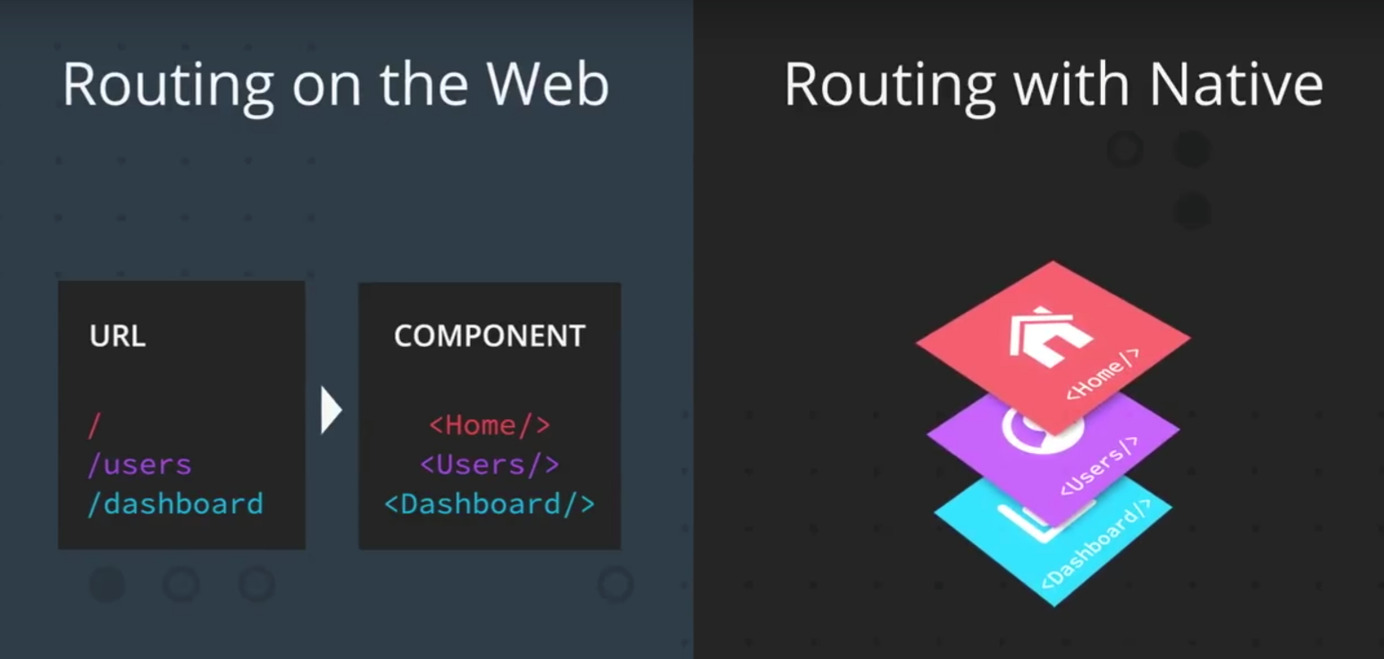](https://classroom.udacity.com/nanodegrees/nd019/parts/197a09ba-b687-4f20-bc15-90a5fb6fad1a/modules/cd7c26c1-308f-41cf-a612-64e3b0006fde/lessons/fc9a2330-8c19-492d-8363-0098c473fef2/concepts/43126136-c3c0-4120-b5fe-4a45b0c3919a)](https://classroom.udacity.com/nanodegrees/nd019/parts/197a09ba-b687-4f20-bc15-90a5fb6fad1a/modules/cd7c26c1-308f-41cf-a612-64e3b0006fde/lessons/fc9a2330-8c19-492d-8363-0098c473fef2/concepts/43126136-c3c0-4120-b5fe-4a45b0c3919a)**

#### Tab Navigator

By using Tab Navigator, users can navigate through different screens within an application simply by pressing tabs that render different components.

**import** { createBottomTabNavigator } **from** 'react-navigation';

Once this is done, we can pass an object into createBottomTabNavigator like so:

**const** Tabs = createBottomTabNavigator({

Hello: {

screen: Hello

},

Goodbye: {

screen: Goodbye

},

});

Inside the object, each key-and-value pair represents a single tab. The keys represent the name of the tab; this is what users will see and press. Note that a screen property is included as well; this is the component that is rendered when the tab is active.

Here comes the interesting part: what createBottomTabNavigator returns is actually a component! Since we have stored this in a Tabs variable, we can just render this as we would with any component:

*// App.js*

*// ...*

**export** **default** **class** **App** **extends** **React**.**Component** {

render() {

**return** (

<Tabs />

);

}

}

To switch from one tab to another, you'd use this.props.navigation.navigate. How would you go back or get screen's current state/route? If you need a hint, check out the [**docs**](https://reactnavigation.org/docs/en/navigation-prop.html#common-api-reference).